Building Your Own I-Spy Jar

Play at Home * Sensory Play

*I-Spy jars are simple to make and an easy way to entertain your toddler at home or on the go. These jars are suitable for any age, even babies, with supervision. An I-Spy jar is simply a recycled plastic jar filled with interesting small objects and an opaque filler like rice or sand.*

***How to Play with an I-Spy Jar at Any Age***

Depending on the age of the child, they can play with this jar in different ways.

* Babies can examine the jar while laying on their tummies. They can roll or shake the jar and observe the objects and the movement of the rice around the objects.
* Toddlers can describe the objects they see as they roll the jar in their hands. Parents can prompt toddlers to look for certain objects in the jar.
* Preschool-aged children and older can play I-Spy with the jar. (One player says, “I spy with my little eye something that is [insert color name].” The other player guesses what that object is based on the color clue.)

Supplies

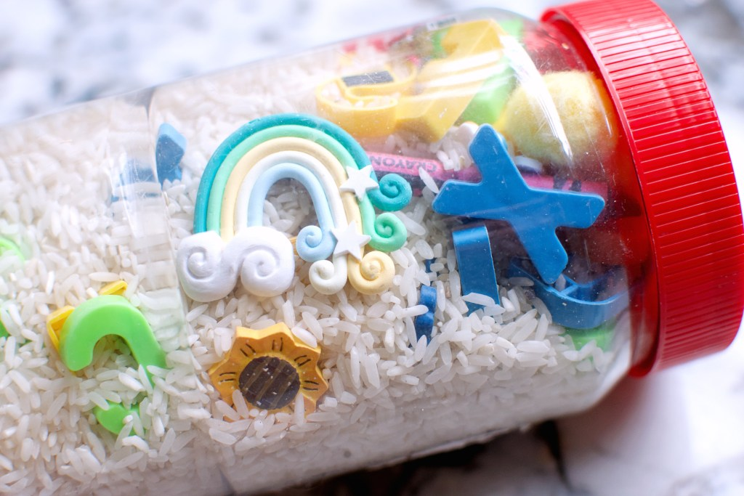To make an I-Spy jar, you will need a clear container. Recycled Fluff jars work nice (and you don’t have to worry about peanut allergies as you will if you use a peanut butter jar). Gummy vitamin jars are also nice and easy to use since the lid is already child-proof, meaning that you won’t have to glue it shut. Tip: Use an adhesive remover like Goo-Gone to remove any sticky residue from the jar where the label was. You will also need a neutral filler like uncooked rice or sand and small objects (that can be gathered from your nature walk).